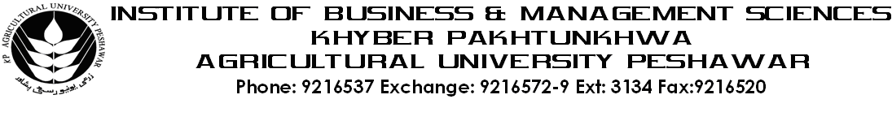
Program: BS(CS)-III
Course Title Data Base Systems
Course Code: CS-402
Session: 2011-2014
Credit Hours: 03
Course Week: 16
Total Credit Hours: 48

Course Objectives
This course introduces the basic concepts of data management and guides towards the concepts of its application. The course emphasizes on relational data base. The course introduces normalization and other topics like ER model. Data integrity, security, concurrency and recovery and recovery techniques. The course also introduces the basics of SQL.

Week-1-2 -Introduction to Databases
-Data & its types
-Data Vs Information
-Entity & its types
-Attributes & its types
-manual system its merits & demerits

Week-3
-Traditional file approach
-Advantages & Disadvantages of TFA
-Database Approach
-Comparative study between TFA & DBMS

Week-4
-Component of DBMS
-Database Administrator
-Database
-DBMS
-Application Programmer
-User
-Data Dictionary & Directory

Week-5
-Key and its types
-Association and its types

Week-6
-Introduction Relational Data Model

Week-7
-Entity Relationship Model

Week-8-9
-Normalization concept
-1NF, 2NF, 3NF BCNF
-Transforming of ER-Diagram to Relations

Week-10-11
-Concurrency, its problems & Solutions
-Recovery and recovery techniques
-Integrity control system, constraints
-Security, types, security methods

Week-12
-Basic concepts of relational Algebra

Week-13
-Introduction to SQL using ORACLE
-Data Retrieval Language (Select Statement)
-(Select, From, where, order by clauses)

Week-14
-Introduction to Built in Functions
-Basics single row and Group row Functions

Week-15
-Group by clause
- Introduction to Joining & its Types

Week-16
-Data Manipulation Language
-Insert, Delete, Update Statements
-DDL.

Total Marks: 100
Recommended Books:
- Modern Data Base Management by Jeffery A Hoffer
- Data Base System by Connolly
- Student’s Guide to SQL 8.0

